# SIT315 – Programming Paradigms

TaskM2.T1P: Parallel Matrix Multiplication

### 1. Implement a sequential matrix multiplication program in C or C++.

Written in C++.

<https://github.com/gregorymcintyre/ProgrammingParadigms/tree/master/M2.T1P%20-%20Parallel%20Matrix%20Multiplication>

### 2. At the end of the program, please print the execution time.

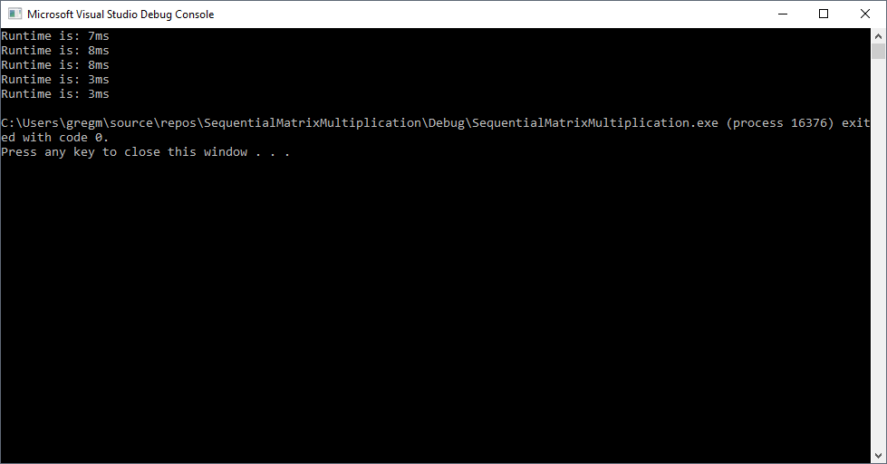

### 3. Once you have completed and tested the program, please review your code and develop a roadmap to parallelise your code.

To parallelise my code, I would like to have the following loop happen in parallel:

value = 0;

for (int k = 0; k < n; k++)

{

value += array1[i][k] * array2[k][j];

}

arrayOut[i][j] = value;

The array values are independent of each other and should be able to be implemented parallel. This would mean that all array values would be calculated concurrently, this should improve the performance of the program significantly.

### 4. Implement your parallel algorithm in C or C++ using pthread library

Same Git

<https://github.com/gregorymcintyre/ProgrammingParadigms/tree/master/M2.T1P%20-%20Parallel%20Matrix%20Multiplication>

### 5. Evaluate the performance of your program

### 6. Modify your sequential program to use OpenMP to achieve parallelism

Same Git

<https://github.com/gregorymcintyre/ProgrammingParadigms/tree/master/M2.T1P%20-%20Parallel%20Matrix%20Multiplication>

### 7. Evaluate the performance of the OpenMP implementation vs pthread implementation vs the sequential program

### 8. Submit your task as detailed on the submission details section above to OnTrack

Submitted